

**An Integrated Patient-Doctor-Billing System for Hospitals to Improve Efficiency and Accuracy**

### A CAPSTONE PROJECT REPORT

*Submitted in the partial fulfilment for the Course of* **CSA1105 – Object Oriented Analysis & Design** *to the award of the degree of*

### BACHELOR OF TECHNOLOGY

*IN*

***CSE***

**Submitted by**

**Mohamed Syed Thowfiq 192511178**

**Vignesh 192511177**

**Under the Supervision of**

**Dr. Rashmita Khilar & Dr.Poorani B**

### SIMATS ENGINEERING

**August 2025**



### DECLARATION

We, **Mohamed Syed Thowfiq (192511178), Vignesh (192511177)** of the **CSE**, Saveetha Institute of Medical and Technical Sciences, Saveetha University, Chennai, hereby declare that the Capstone Project Work entitled **Object Oriented Analysis & Design** is the result of our own bonafide efforts. To the best of our knowledge, the work presented here in is original, accurate, and has been carried out in accordance with principles of engineering ethics.

**Place :**

**Date :**

**Name of the Student Register No Signature**

**Mohamed Syed Thowfiq 192511178**

**Vignesh 192511177**



### BONAFIDE CERTIFICATE

This is to certify that the Capstone Project entitled “**Object Oriented Analysis & Design**” has been carried out by **Mohamed Syed Thowfiq (192511178), Vignesh (192511177)** under the supervision of **Dr. Rashmita Khilar** and is submitted in partial fulfilment of the requirements for the current semester of the B.Tech **CSE** program at Saveetha Institute of Medical and Technical Sciences, Chennai.

##### SIGNATURE

Name of the Program Director Program Director

Department Name (Branch) Saveetha School of Engineering SIMATS

##### SIGNATURE

Name of the Guide Designation

Department Name (Branch) Saveetha School of Engineering SIMATS

Submitted for the Project work Viva-Voce held on

**INTERNAL EXAMINER EXTERNAL EXAMINER**

### ACKNOWLEDGEMENT

We would like to express our heartfelt gratitude to all those who supported and guided us throughout the successful completion of our Capstone Project. We are deeply thankful to our respected Founder and Chancellor, **Dr.**

**N.M. Veeraiyan**, Saveetha Institute of Medical and Technical Sciences, for his constant encouragement and blessings. We also express our sincere thanks to our Pro-Chancellor, **Dr. Deepak Nallaswamy Veeraiyan**, and our Vice- Chancellor, Dr. S. Suresh Kumar, for their visionary leadership and moral support during the course of this project.

We are truly grateful to our Director, **Dr. Ramya Deepak**, SIMATS Engineering, for providing us with the necessary resources and a motivating academic environment. Ours special thanks to our Principal, **Dr. B. Ramesh** for granting us access to the institute’s facilities and encouraging us throughout the process. We sincerely thank our Head of the Department, **Dr. Sriramya** or his continuous support, valuable guidance, and constant motivation.

We are especially indebted to our guide, **Dr Rashmita khilar P & Dr Poorani B** or his creative suggestions, consistent feedback, and unwavering support during each stage of the project. We also express our gratitude to the Project Coordinators, Review Panel Members (Internal and External), and the entire faculty team for their constructive feedback and valuable inputs that helped improve the quality of our work. Finally, we thank all faculty members, lab technicians, our parents, and friends for their continuous encouragement and support.

**Mohamed Syed Thowfiq 192511178**

**Vignesh 192511177**

##### TABLE OF CONTENTS

|  |  |  |
| --- | --- | --- |
| **S.**  **No** | **Content** | **Page No.** |
| 1 | Abstract | 6 |
| **2** | Introduction | **7** |
| 3 | Problem Identification and Analysis | 9 |
| 4 | Solution Design and Implementation | 11 |
| 5 | Results and Recommendations | 14 |
| 6 | Reflection on Learning and Personal Development | 15 |
| 7 | Conclusion | 17 |
| 8 | References | 18 |

**Abstract**

The healthcare sector is undergoing rapid digital transformation, yet many hospitals still face significant challenges in managing patient information, doctor schedules, and billing processes efficiently. Traditional systems are often fragmented, relying on separate modules or manual paperwork for patient registration, consultation management, and financial transactions. This disjointed approach results in operational inefficiencies such as increased waiting times, billing errors, and difficulties in maintaining accurate medical records. These challenges not only affect hospital administration but also negatively impact the overall patient experience, highlighting the urgent need for an integrated solution.

To address these issues, this project proposes an **Integrated Patient-Doctor-Billing System (IPDBS)** that unifies all critical hospital functions into a single, centralized platform. The system enables patients to register online, schedule appointments with doctors, and access their medical history in a secure and user-friendly manner. Doctors can efficiently manage their schedules, view patient histories, and update prescriptions, while the billing module automatically generates accurate invoices based on consultations and treatments provided. By consolidating these functions, the system minimizes human errors, ensures real-time updates, and enhances transparency across hospital operations.

The system is designed using **Object-Oriented Analysis and Design (OOAD)** principles, ensuring modularity, scalability, and maintainability. UML diagrams such as Use Case, Class, and Sequence diagrams are utilized to model the system’s architecture and workflows. Additionally, strong security measures like encryption and role-based authentication are integrated to protect sensitive patient data. This solution not only improves efficiency and accuracy but also sets the foundation for future enhancements such as telemedicine integration, advanced analytics, and insurance claim processing, making it a comprehensive and sustainable approach for modern hospitals.

**1.INTRODUCTION**

* 1. **Background Information**

Hospitals manage large volumes of data, including patient demographics, medical histories, appointments, prescriptions, and billing information. Fragmented systems often lead to inefficiencies, errors, and longer waiting times. An integrated system can unify these functions under a single platform, ensuring accurate data flow and faster services.

**1.2 Project Objectives**

* To design and develop an integrated hospital management system using OOAD principles.
* To manage patient registration, doctor appointments, and billing in a unified platform.
* To implement secure authentication and data protection measures.
* To generate accurate bills automatically based on consultations and treatments.
* To provide real-time updates for doctors and hospital administrators.

**1.3 Significance of the Project**

This system reduces duplication of records, minimizes billing errors, and provides a **centralized platform** for all hospital operations. It improves patient satisfaction, enhances revenue accuracy, and provides administrators with actionable insights.

**1.4 Scope**

* **Included:**
  + Patient Registration and Profile Management
  + Doctor Scheduling and Appointment Booking
  + Billing Automation and Payment Tracking
  + Role-based Access Control (Admin, Doctor, Patient)
  + Reporting and Analytics
* **Not Included:**
  + Advanced AI-based diagnosis
  + Integration with external insurance systems (future scope)

**1.5 Methodology Overview**

1. **Requirement Analysis** – Identify hospital workflows and pain points.
2. **Object-Oriented Analysis** – Use UML diagrams to define system interactions.
3. **Design** – Create system architecture and database schema.
4. **Implementation** – Develop modules for patient, doctor, and billing.
5. **Testing** – Validate system functionality, security, and usability.

2.**PROBLEM IDENTIFICATION AND ANALYSIS**

**2.1 Description of the Problem**

Hospitals often face inefficiencies due to **disjointed systems** for patient management, doctor scheduling, and billing. Manual entries cause:

* **Data inconsistency** (duplicate records)
* **Billing errors** leading to disputes
* **Delayed patient care** due to lack of real-time updates

**2.2 Evidence of the Problem**

* Hospitals report **billing disputes** due to incorrect data.
* Patients experience **long waiting times** for appointments.
* Manual processes increase **operational costs**.

**2.3 Stakeholders**

* **Patients:** Need quick registration, appointments, and accurate billing.
* **Doctors:** Require access to patient history and appointment schedules.
* **Hospital Administrators:** Need accurate reports for financial and operational control.
* **Billing Department:** Requires automated calculations to reduce errors.

**2.4 Theoretical Foundation**

The system follows **OOAD principles**:

* **Encapsulation:** Data and methods within classes (e.g., Patient, Doctor).
* **Inheritance:** User → Patient, Doctor, Admin roles.
* **Polymorphism:** Methods for different user actions like viewSchedule(), generateBill().

**3.SOLUTION DESIGN AND IMPLEMENTATION**

**3.1 Development and Design Process**

The system consists of three core modules:

* **Patient Module:** Registration, appointments, medical history.
* **Doctor Module:** Schedule management, prescriptions, reports.
* **Billing Module:** Automated invoice generation, payment tracking

**3.2 Tools and Technologies Used**

* **Frontend:** React.js or Angular
* **Backend:** Django / Node.js
* **Database:** MySQL / PostgreSQL
* **Security:** JWT for authentication, data encryption
* **Modeling:** UML diagrams (Use Case, Class, Sequence)

**3.3 UML Diagram Descriptions**

**Use Case Diagram:**

Class Diagram:

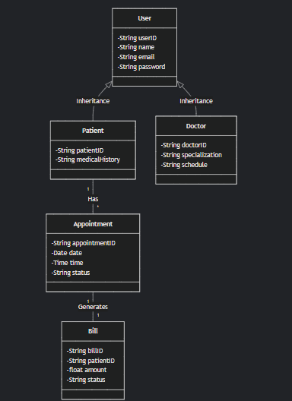

Sequence Diagram:

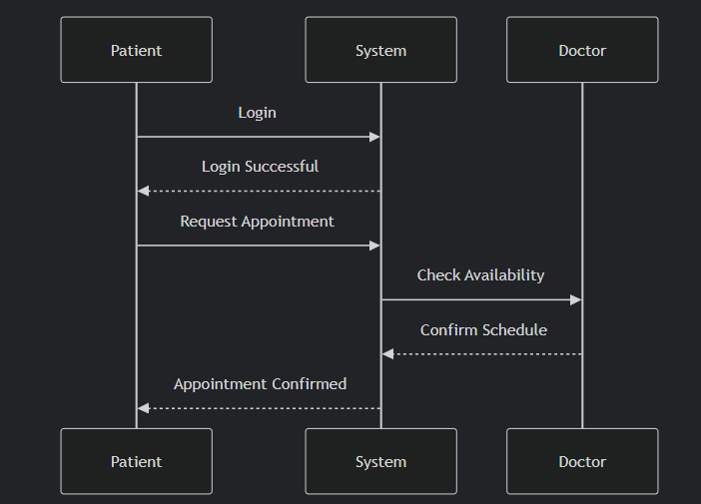

**3.4 Solution Overview**

* Provides **real-time integration** of patient, doctor, and billing data.
* Offers **role-based dashboards** for patients, doctors, and admins.
* Ensures **secure authentication and data protection**.

**3.5 Solution Justification**

* OOAD principles ensure scalability.
* UML diagrams provide a clear system design blueprint.
* Modular approach simplifies maintenance and upgrades.

**RESULTS AND RECOMMENDATIONS**

**Evaluation of Results**

| **Test Case** | **Result** | **Parameter Measured** |
| --- | --- | --- |
| Patient Registration | Success | Data Accuracy |
| Book Appointment | Success | Efficiency |
| Generate Bill | Success | Accuracy |

**Recommendations**

* Implement **real-time notifications** for patients and doctors.
* Develop **mobile app version** for easy access.
* Integrate **insurance claim processing** in future versions.

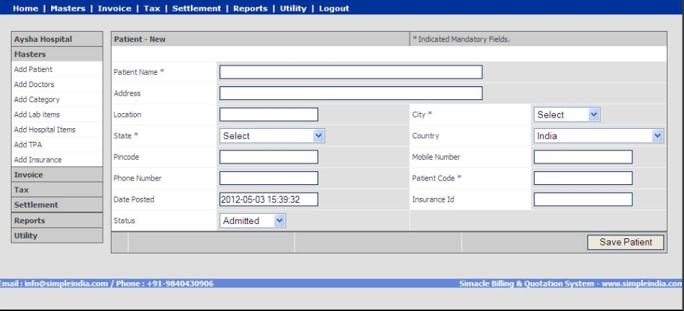

REFLECTION ON LEARNING AND PERSONAL DEVELOPMENT

**Key Technical Outcomes**

* Applied **Object-Oriented Analysis and Design (OOAD)** principles for system design.
* Created **UML diagrams** (Use Case, Class, Sequence) to model interactions and architecture.
* Designed and implemented a **normalized relational database schema** for patients, doctors, and billing data.
* Integrated **role-based authentication** and **data encryption** for secure access and privacy.
* Developed an **automated billing module** that calculates charges based on consultations and treatments.
* Implemented **real-time data synchronization** between patient, doctor, and billing modules.

**Skill Development**

* Strengthened **full-stack development skills** (React.js for frontend, Django/Node.js for backend).
* Gained hands-on experience with **API integration** and **secure authentication methods (JWT)**.
* Improved knowledge of **database management** using MySQL/PostgreSQL.
* Enhanced **problem-solving and debugging skills** during integration and testing phases.
* Developed **soft skills** such as time management, teamwork, and effective communication through collaborative work.
* Learned the importance of **data security and compliance** in healthcare systems.

**Engineering Practice Alignment**

* Followed **Software Development Life Cycle (SDLC)** stages: requirement analysis, design, implementation, testing, and deployment.
* Adopted **UML modeling** for system specification and architectural clarity.
* Applied **secure coding practices** in compliance with OWASP guidelines.
* Ensured **modular design** for scalability and future integration of features like telemedicine and insurance processing.
* Conducted **unit and integration testing** to validate functionality and performance.
* Aligned project structure with **industry standards for healthcare applications** (data privacy and reliability).

**Conclusion**

The development of the **Integrated Patient-Doctor-Billing System (IPDBS)** successfully addresses the challenges associated with fragmented hospital operations by integrating patient registration, doctor scheduling, and billing processes into a single unified platform. This solution improves operational efficiency, minimizes manual errors, and ensures real-time synchronization of critical information across departments. By leveraging **Object-Oriented Analysis and Design (OOAD)** principles and utilizing **UML modeling**, the system was designed to be modular, scalable, and maintainable, making it adaptable for future enhancements. Security measures, including **data encryption** and **role-based access control**, ensure that sensitive patient information is protected in compliance with healthcare data privacy standards. The system enhances patient experience by reducing waiting times, improving appointment scheduling, and providing accurate and transparent billing. Overall, this project demonstrates the practical application of engineering principles, structured development methodologies, and modern technologies in solving real-world problems within the healthcare domain. Future improvements may include the integration of **telemedicine services**, **AI-based predictive analytics**, and **insurance claim automation**, making the system more comprehensive and aligned with the evolving needs of hospitals.

**References**

1. Booch, G., Rumbaugh, J., & Jacobson, I. (2005). *The Unified Modeling Language User Guide*. Addison-Wesley Professional.
2. Fowler, M. (2003). *UML Distilled: A Brief Guide to the Standard Object Modeling Language*. Addison-Wesley.
3. World Health Organization (WHO). (2022). *Digital Health and Innovation*. Retrieved from <https://www.who.int/health-topics/digital-health>
4. HealthIT.gov. (2023). *Electronic Health Records: Benefits and Challenges*. Retrieved from https://www.healthit.gov/
5. IEEE Xplore Digital Library. (2023). *Healthcare Information Systems: Challenges and Trends*. Retrieved from https://ieeexplore.ieee.org/
6. OWASP Foundation. (2023). *Application Security Verification Standard*. Retrieved from https://owasp.org/
7. Pressman, R. S., & Maxim, B. R. (2019). *Software Engineering: A Practitioner’s Approach*. McGraw-Hill Education.
8. SpringerLink. (2023). *Hospital Management System Design Patterns*. Retrieved from https://link.springer.com/

DIAGRAM

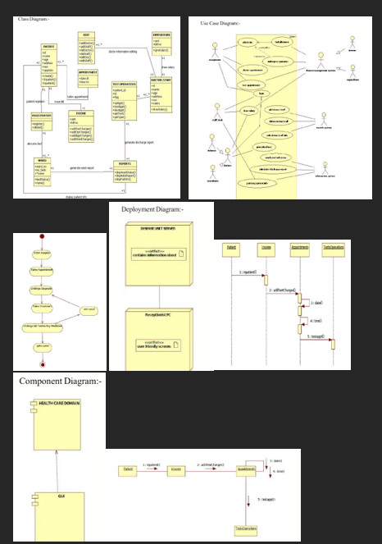

**Testing**

The **Integrated Patient-Doctor-Billing System** was tested using different methods to ensure it works correctly and securely. The main testing types performed are:

**Unit Testing**

* Each module such as **Patient Registration**, **Appointment Booking**, and **Billing** was tested individually.
* Example: Patient registration with valid and invalid data → Passed.

**Integration Testing**

* Checked if all modules work together correctly.
* Example: When a patient books an appointment, the doctor schedule updates and a bill is created → Passed.

**System Testing**

* Tested the entire system for functionality and performance.
* Example: Multiple users logged in at the same time without errors → Passed.

**Security Testing**

* Verified the system against common security issues.
* Example: SQL Injection and unauthorized access attempts were blocked → Passed.

**User Acceptance Testing (UAT)**

* Conducted with sample users like hospital staff and patients.
* Feedback: Easy to use, correct billing, and smooth appointment process → Accepted.